**PROJECT REPORT**

**REAL-TIME RIVER WATER QUALITY MONITORING AND CONTROL SYSTEM**

**INTRODUCTION:**

**Project Overview:**

Water pollution is one of the biggest and serious threats to society. Water has a significant impact on human health. The quality of the water must be monitored in real-time to ensure its safety and supply. Monitoring water in traditional ways takes longer, which can take up to from 24 to 96 hours to identify contaminants in water supplies, which are more time taking. This project aims at developing a water quality monitoring system using sensors and IoT (Internet of Things). The water quality parameters like temperature, pH, and turbidity are measures using sensors and the water quality index is determined. The measured values from the sensors will be processed using a microcontroller, and alert message will be sent to the user via an android application developed using MIT app inventor in case of any abnormalities. The sensor data can be viewed on the ThingSpeak GUI platform for monitoring and correction of the critical water quality parameters. The sensed data will be stored in the cloud or local storage and a machine learning algorithm will be implemented using the sensed parameters to predict the short term and long-term water quality in phase two of the project.

**Purpose:**

Water is the primary need of all living beings and living without water is impossible. With the advancement of technology and industrialization, environmental pollutions have become a major concern. Water pollution is one of the most serious types of this environmental pollution. Our lives depend on the quality of water that we consume in different ways, from juices which are produced by the industries. Any imbalance in the quality of water would severely affect the humans health and at the same time it would affect the ecological balance among all species. Water quality refers to the chemical, biological, radiological, and biological parameters of the water

.The essential parameters of the water quality vary based on the application of water. For example, for aquariums, it is necessary to maintain the temperature, pH level, dissolved oxygen level, turbidity, and the level of the water in a certain normal range in order to ensure the safety of the fish inside the aquarium. For the industrial and household applications, however, some parameters of the water are more essential tobe monitored frequently than the others, depending on the usage of the water.

**Literature Survey:**

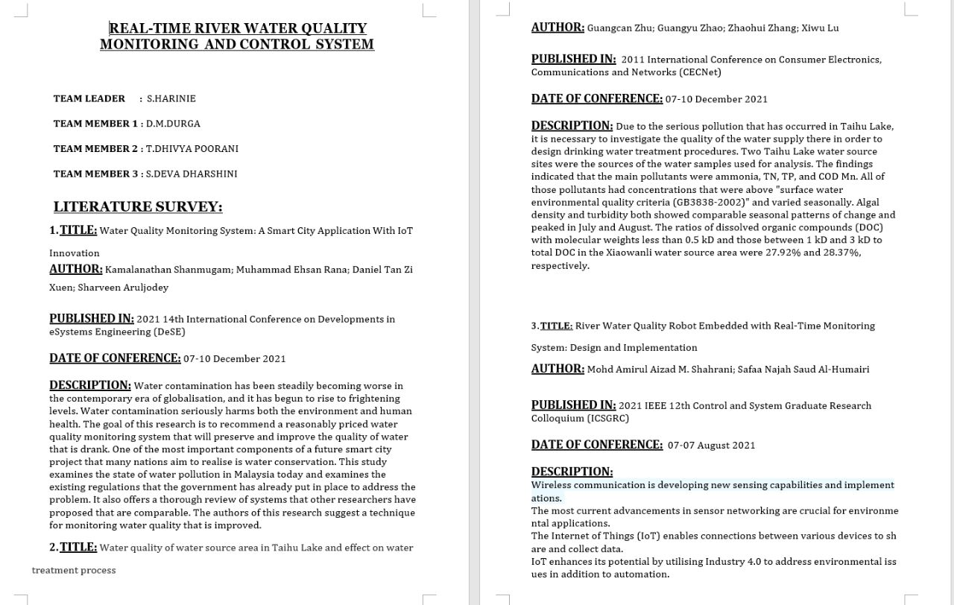

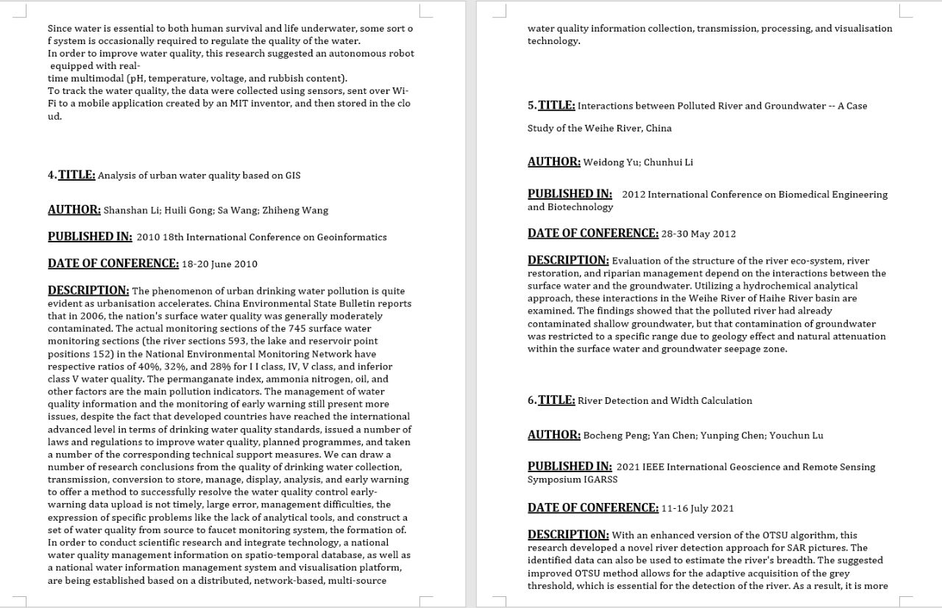

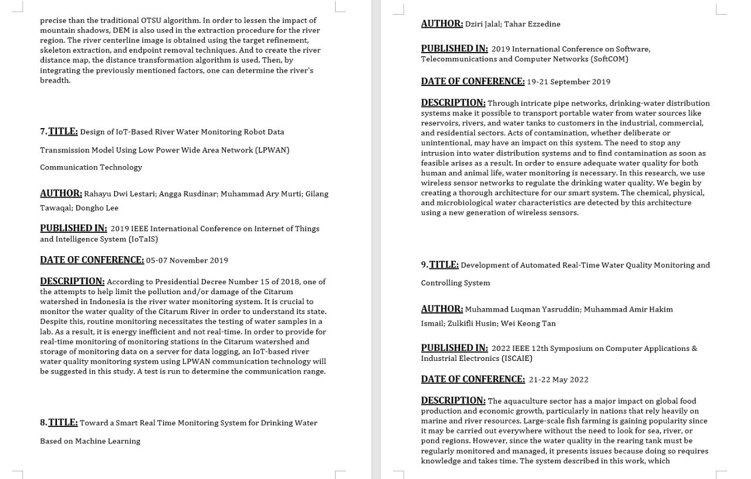

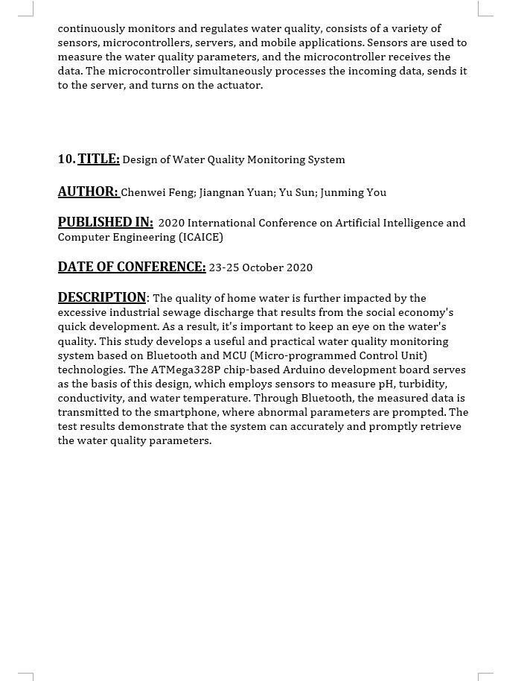

**Ideation & Proposed Solution:**

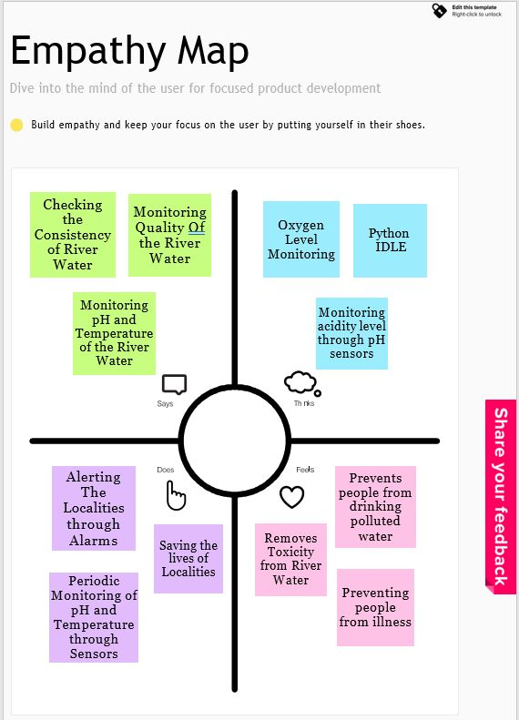

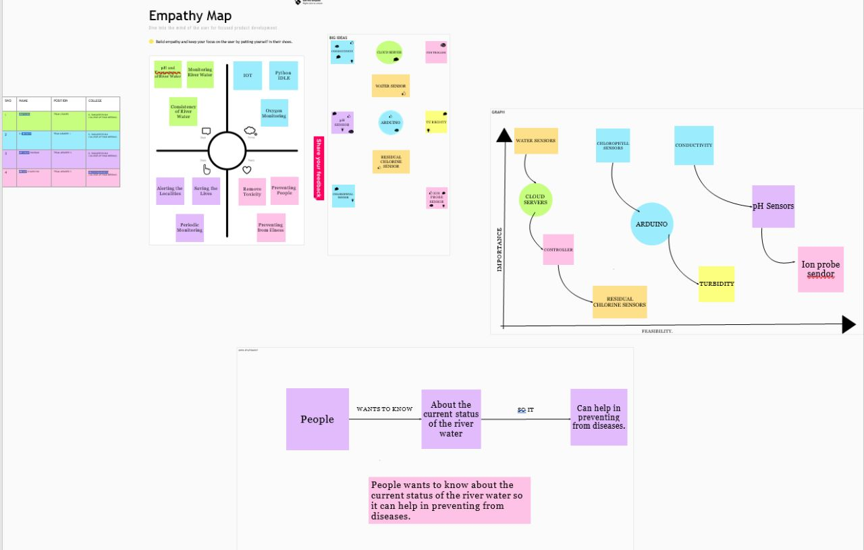

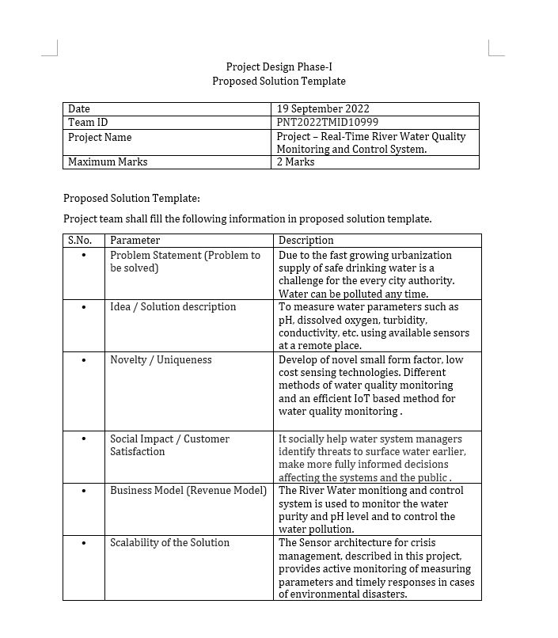

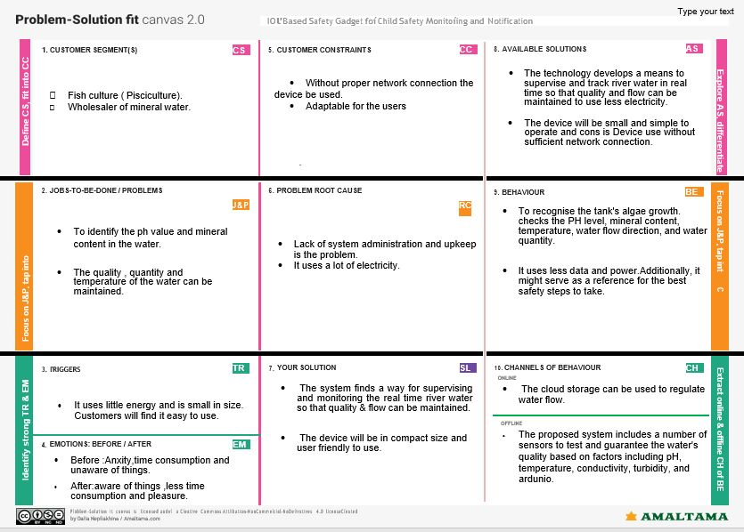

**Requirement Analysis:**

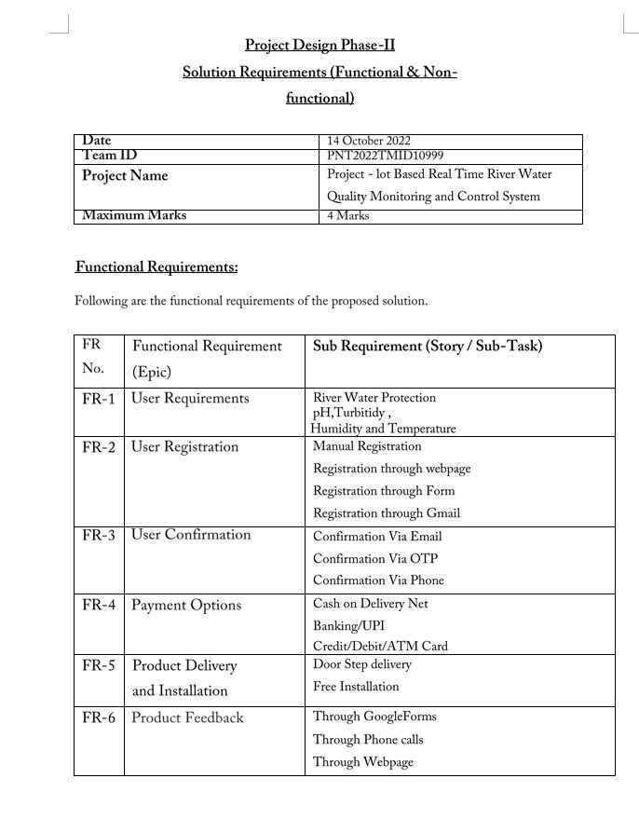

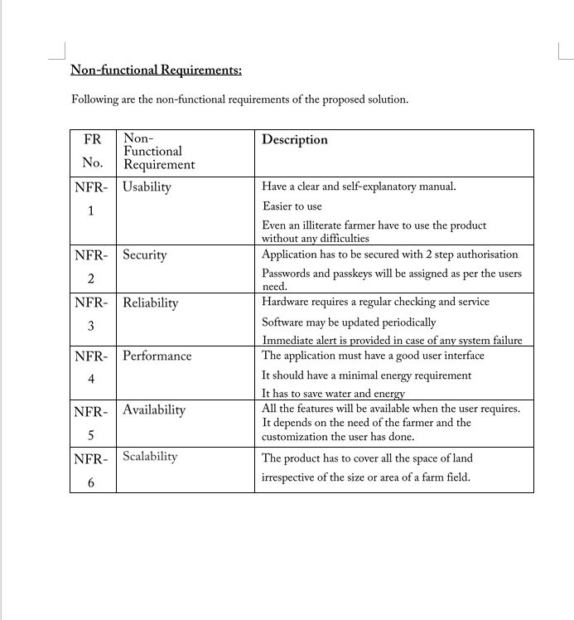

**Project Design:**

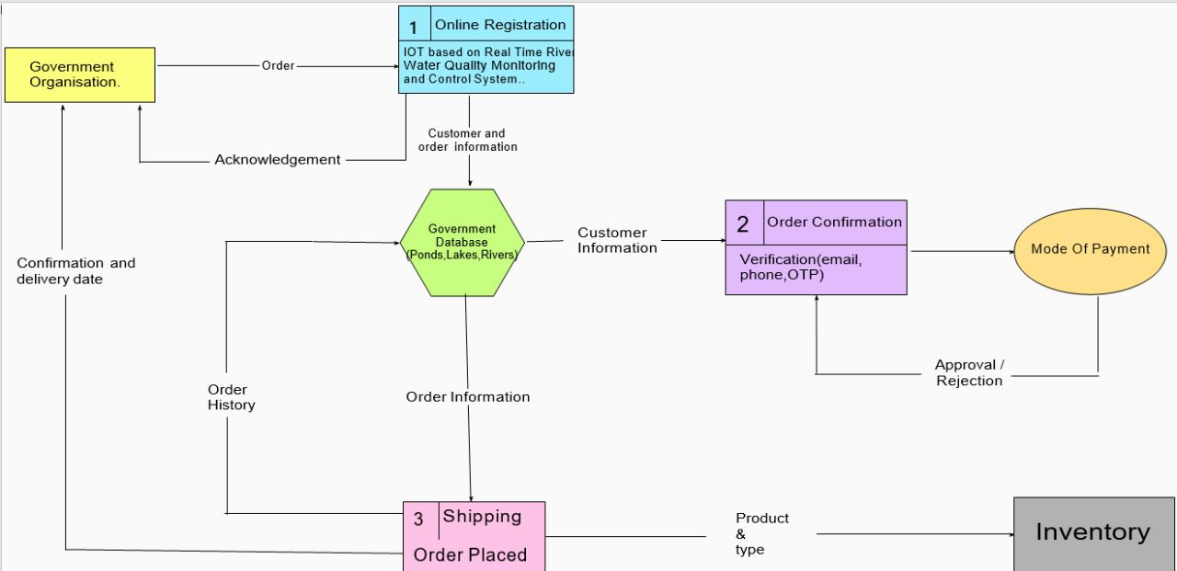

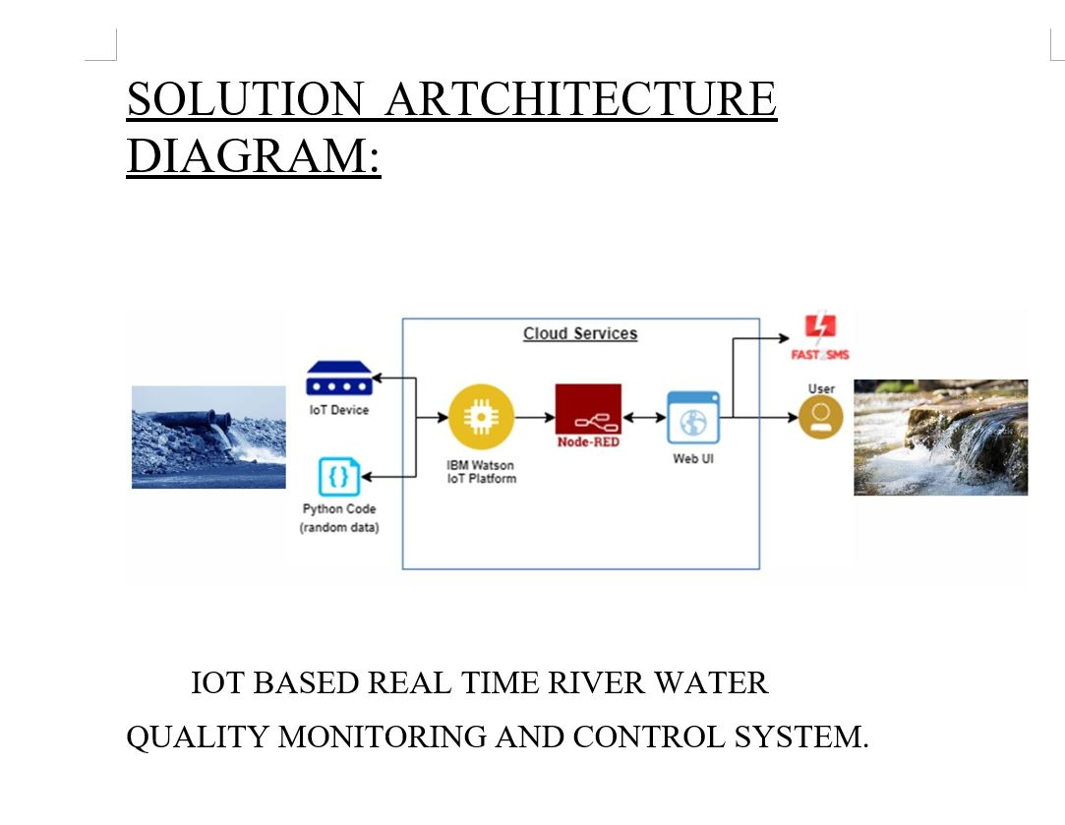

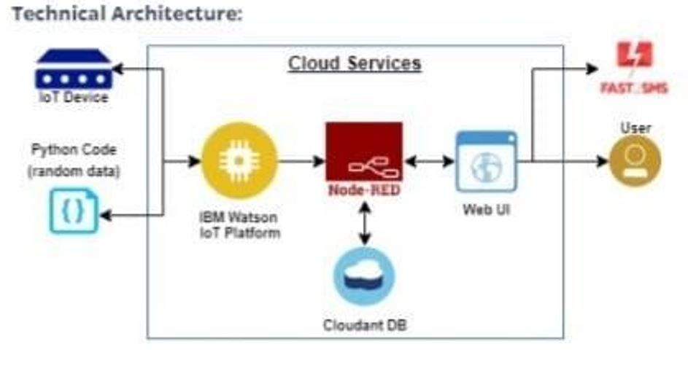

**User Stories:**

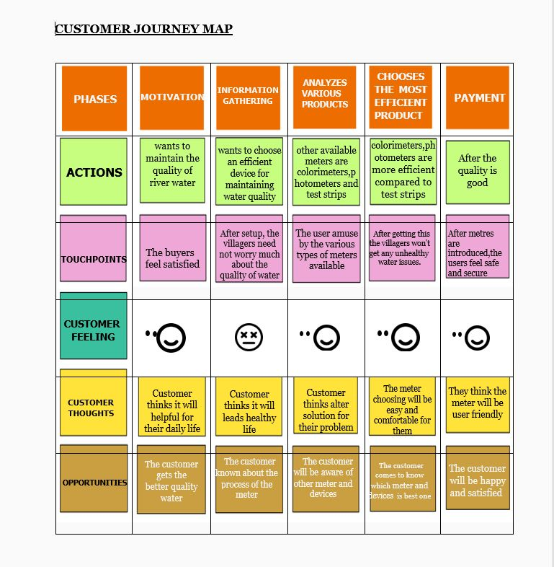

**Project Planning & Scheduling:**

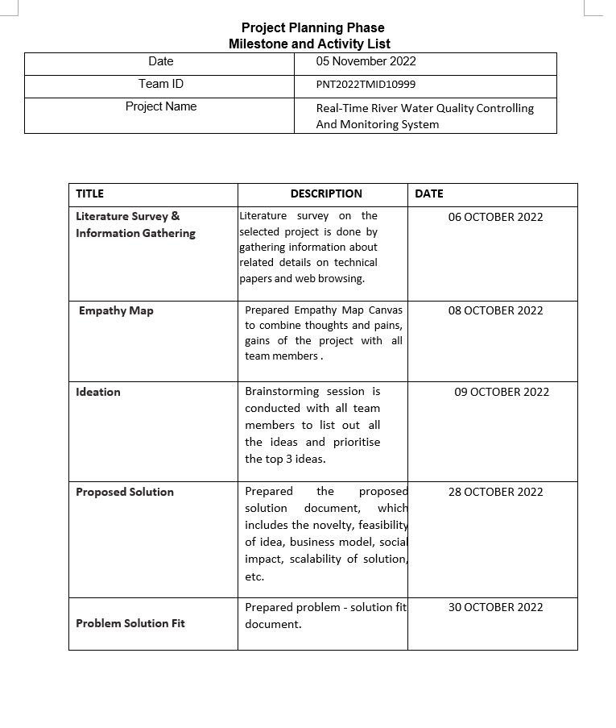

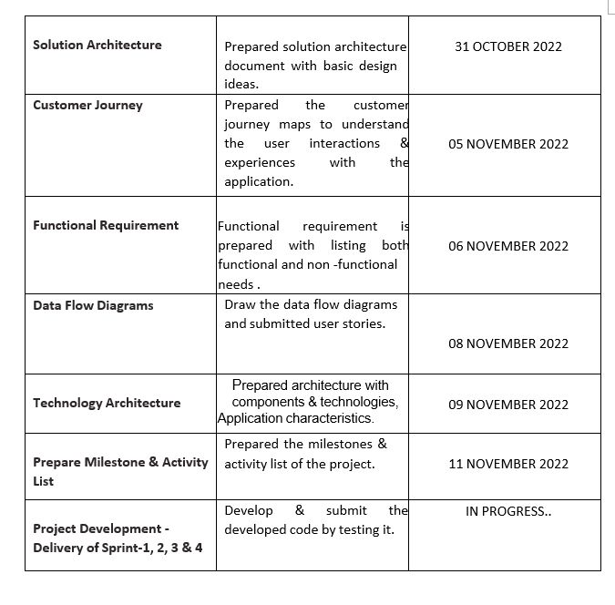

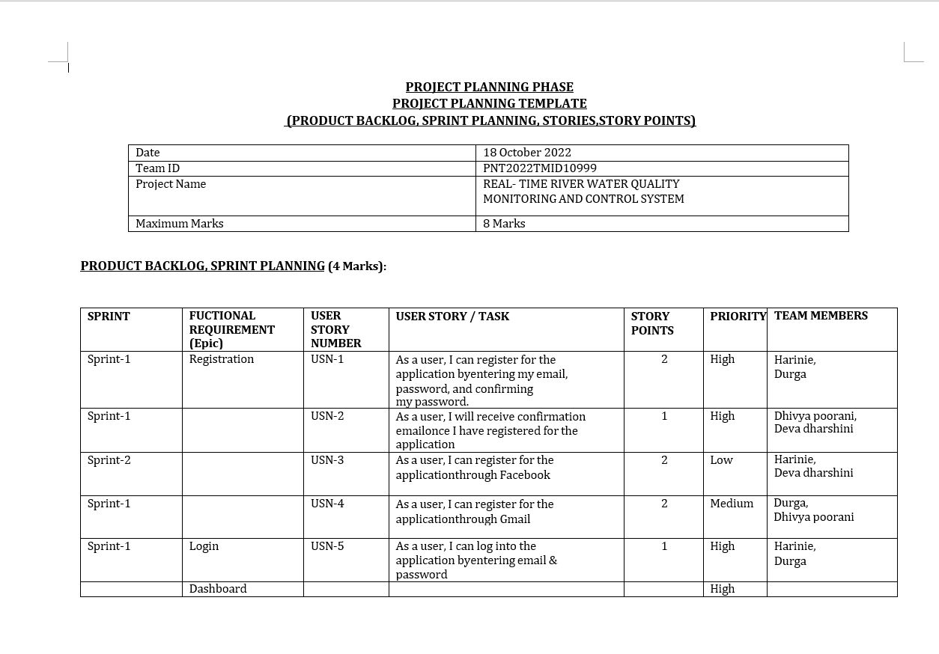

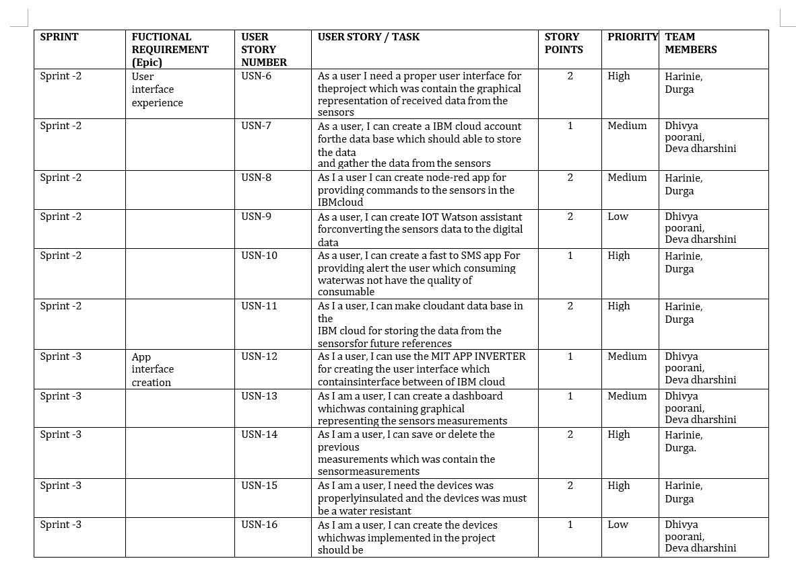

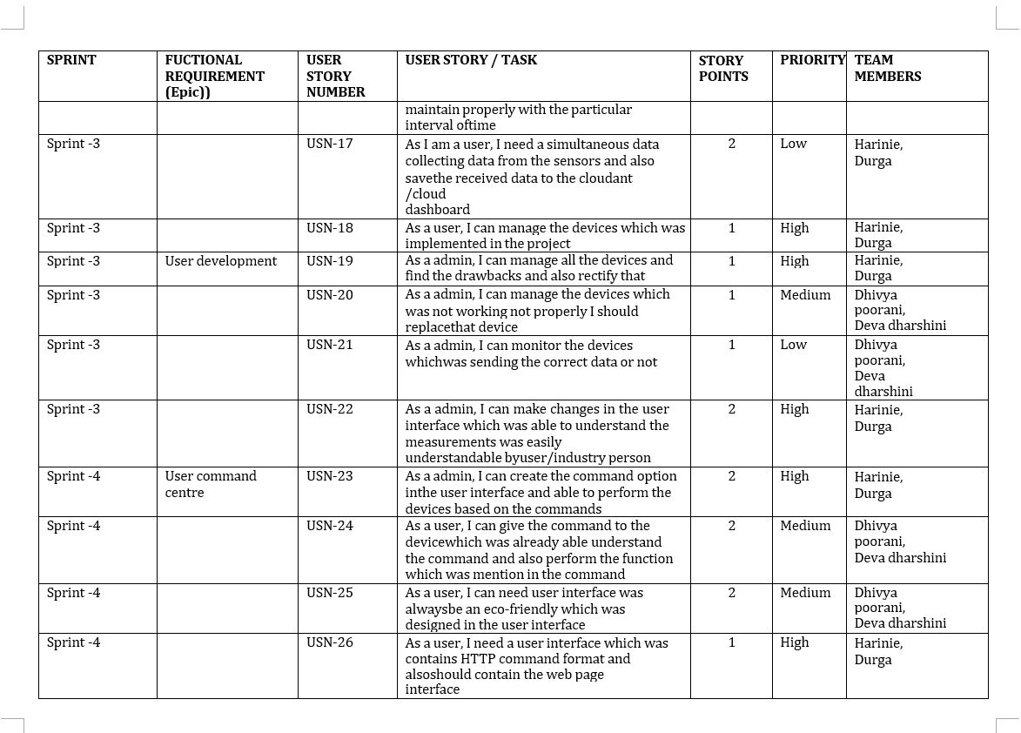

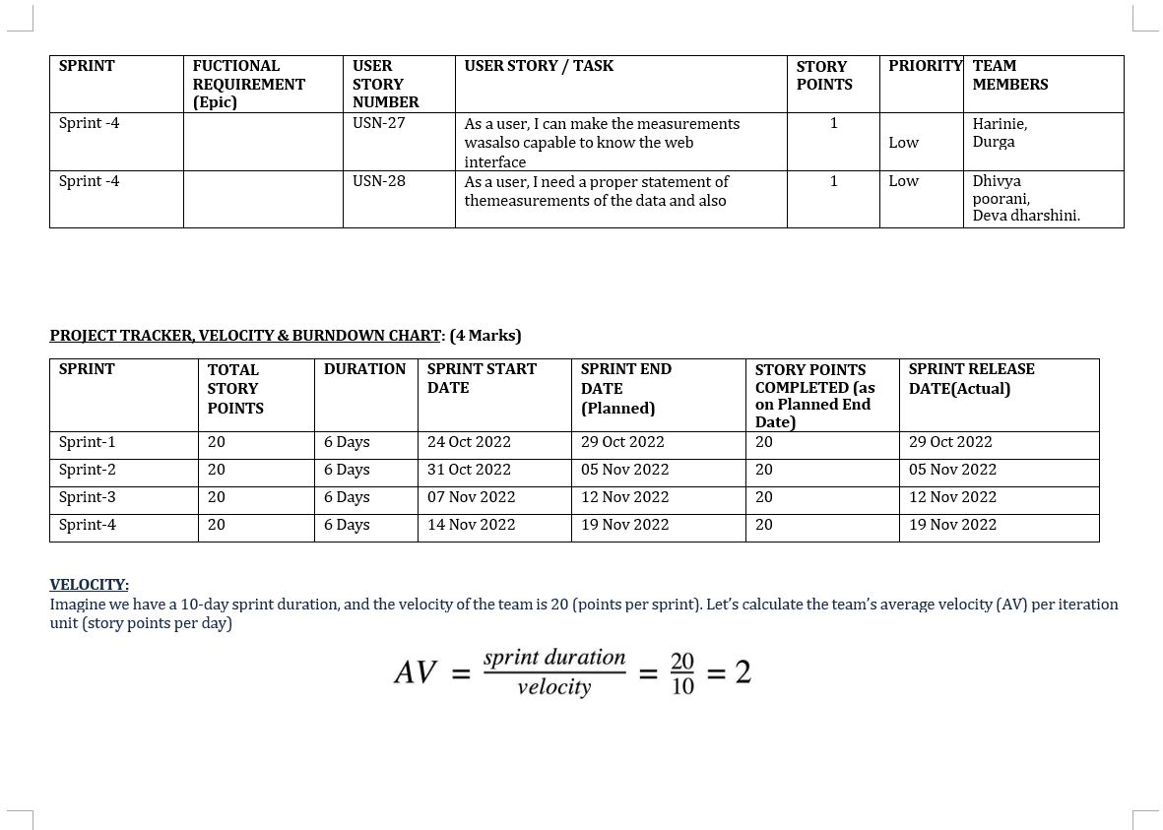

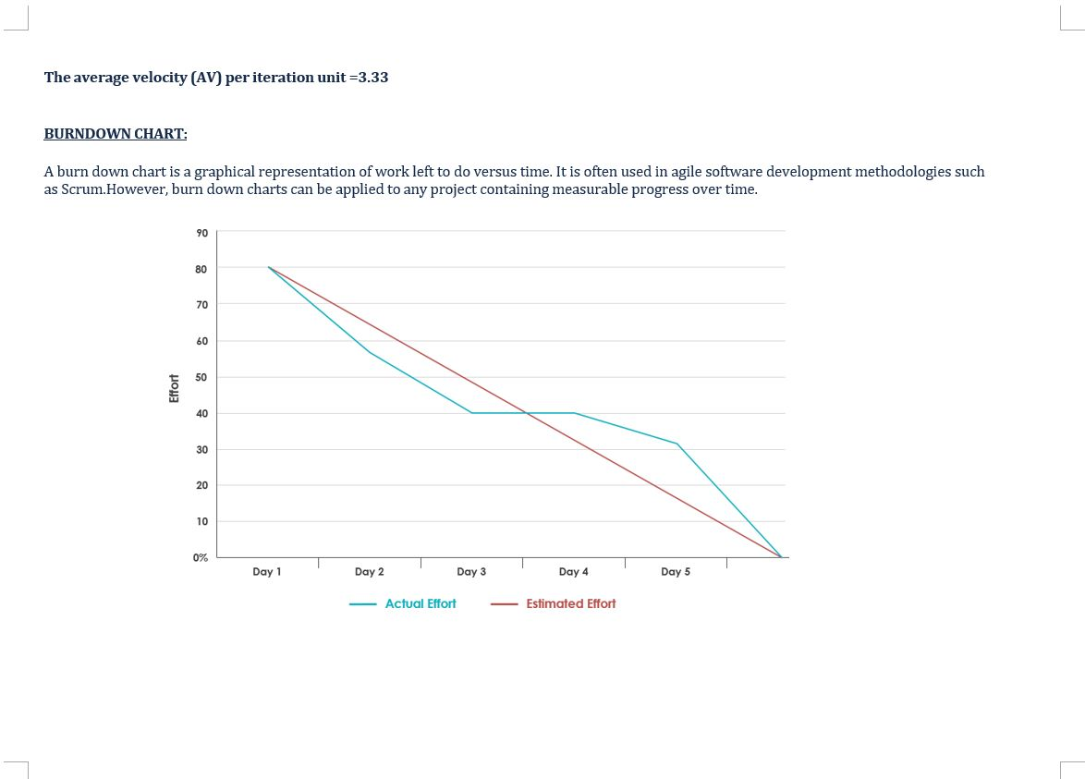

**Coding & Solution:**

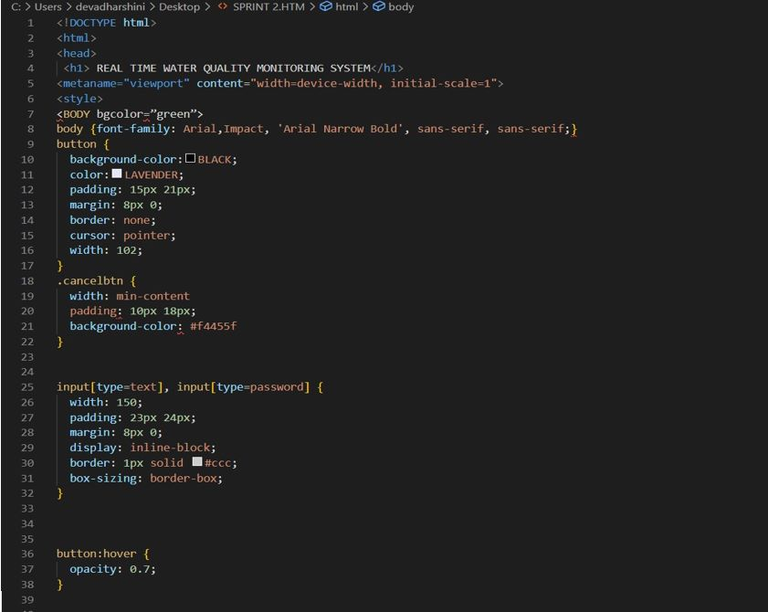

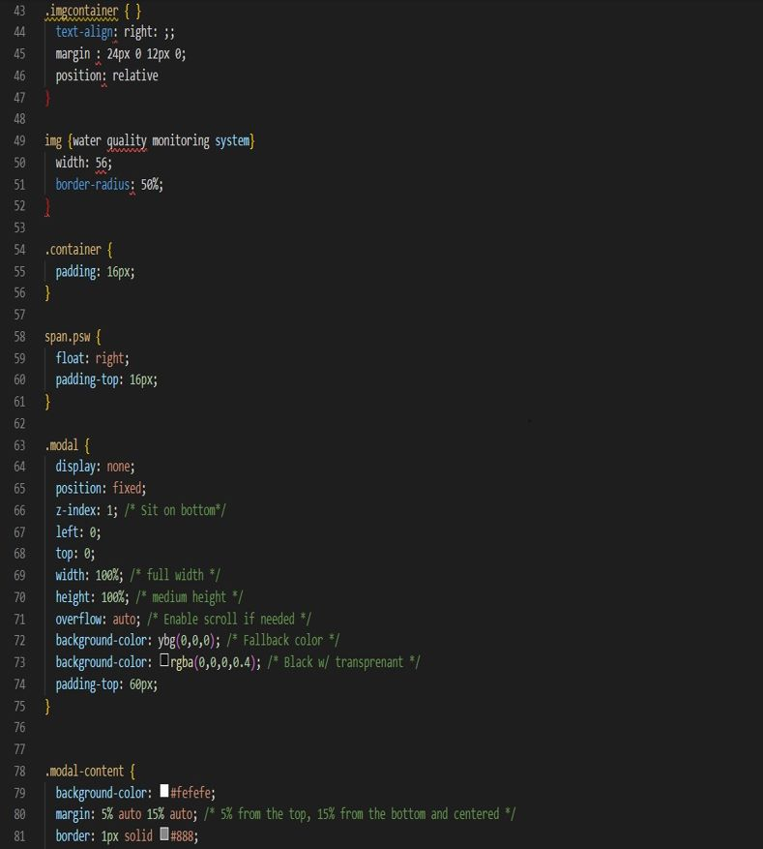

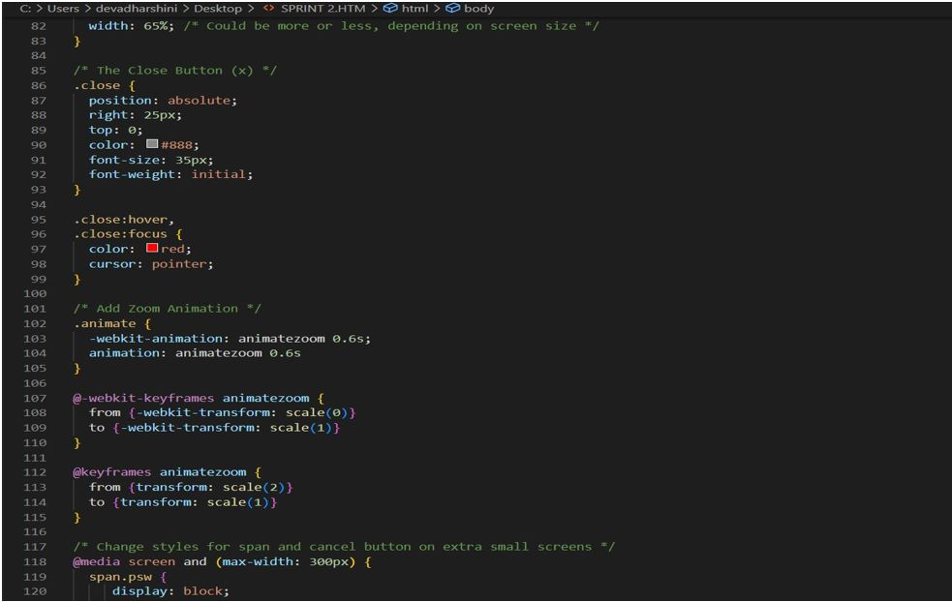

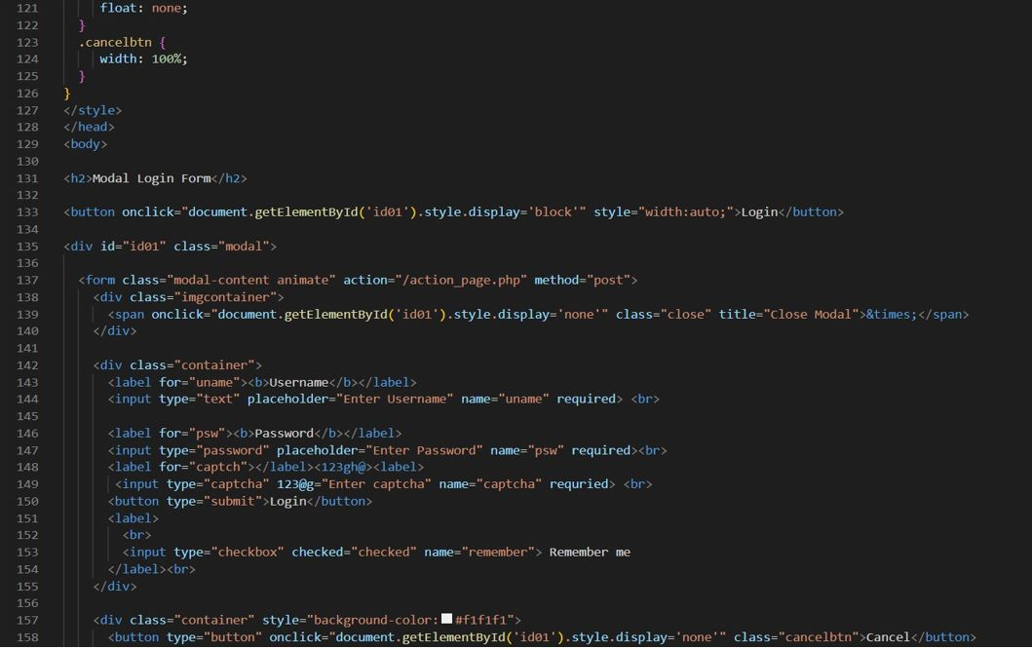

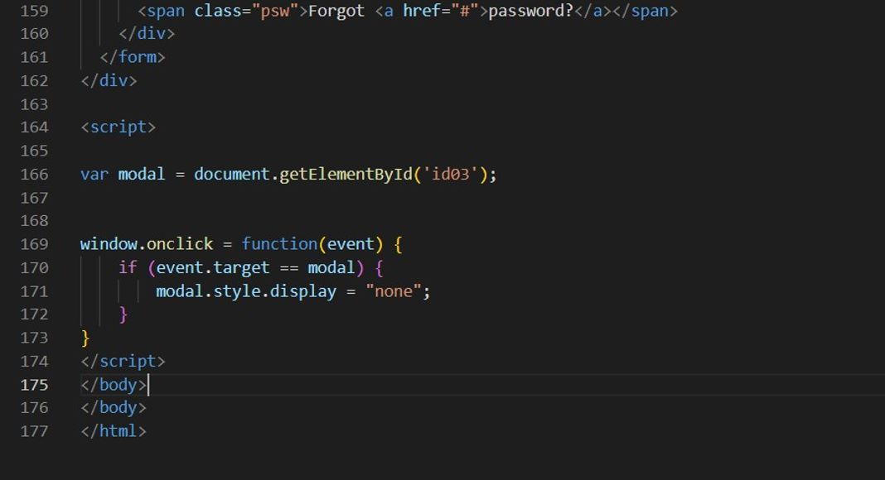

**Testing:**

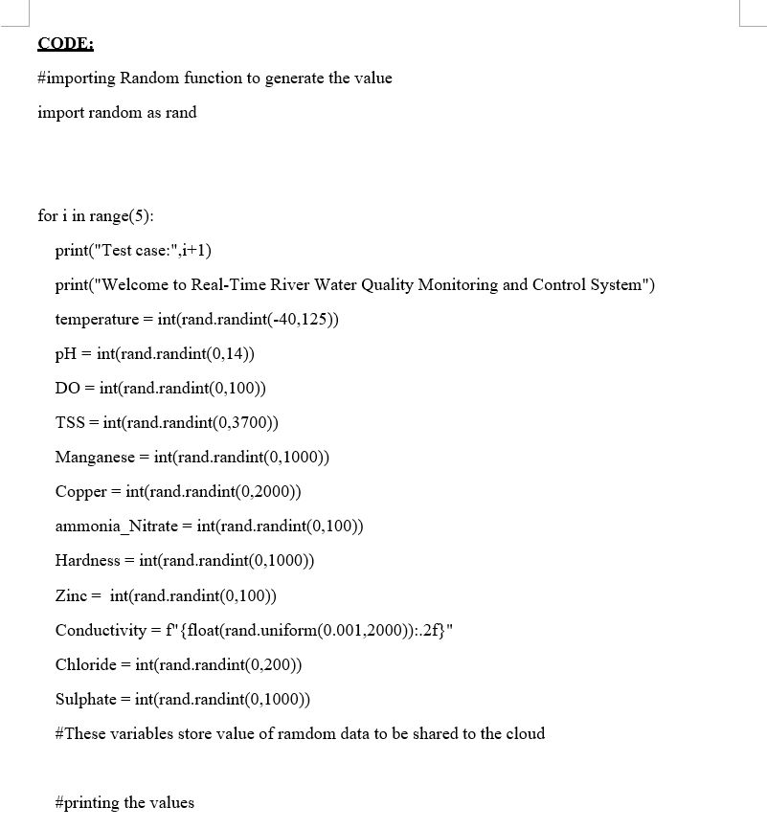

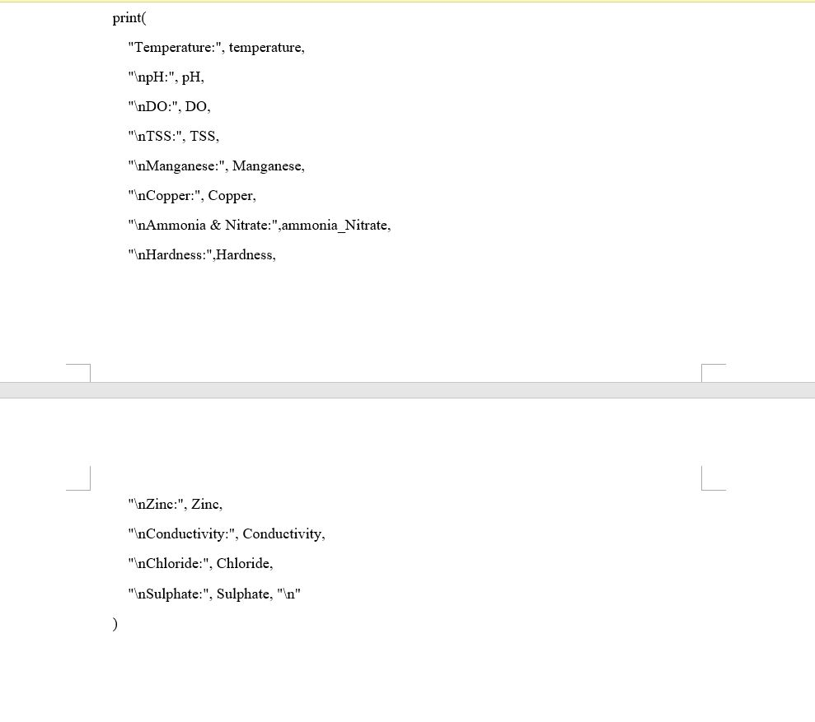

**Results:**

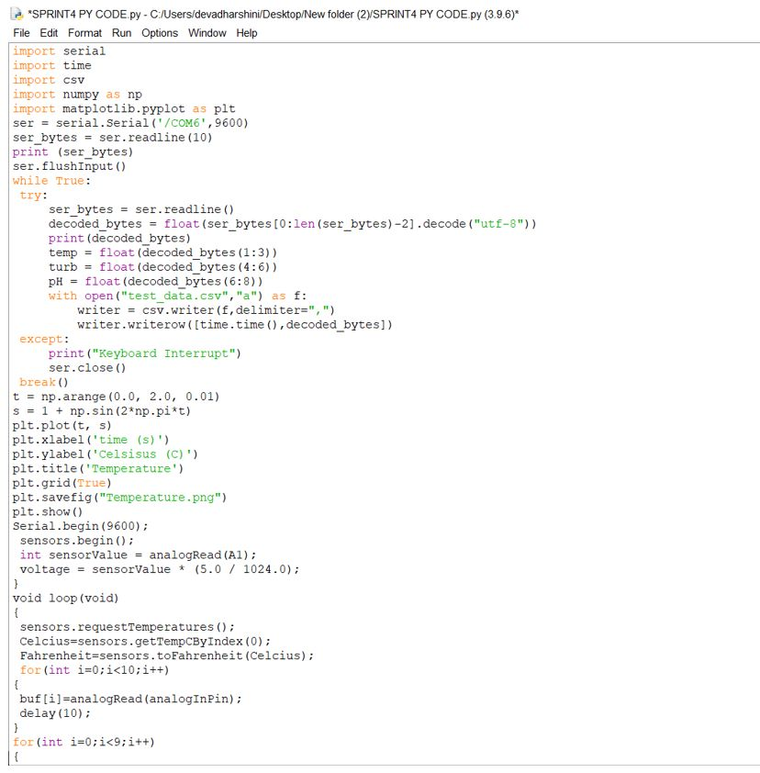

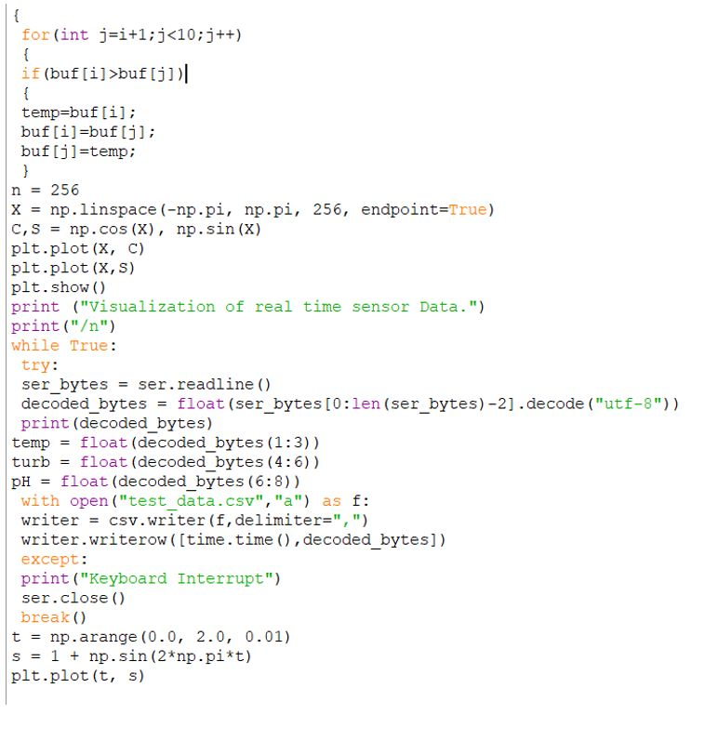

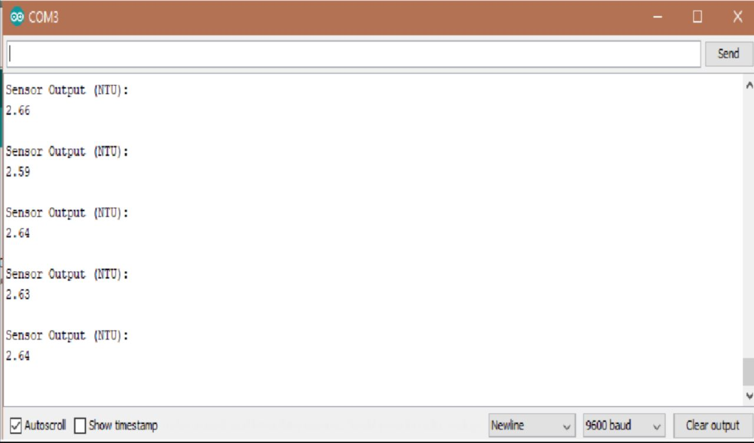

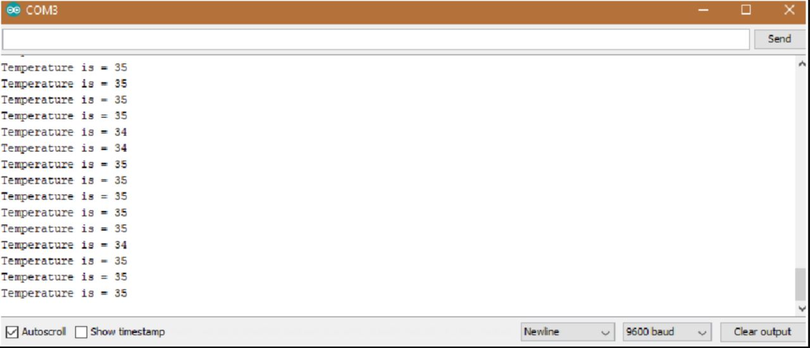

**Advantages:**

1. Ease and convenience of usage
2. Instantaneous data
3. Improved accuracy of measurements
4. Contact guardian water treatment today

**Conclusion:**

The various methods for network design available in the hydrologic literature were evaluated by taking into account the monitoring program's spatial scale, sampling objectives, data requirements, temporal effects, and applicability range. To track water quality, an efficient real-time algorithm should be developed. In an IoT environment, a hardware/software based smart sensor interface device for Water Quality Monitoring can intelligently collect sensor data. It's ideal for the real-time and costeffective needs of a highspeed data acquisition system in an IoT environment.